Evaluate a science experiment on energy
Below is a science report done by students for a science fair. The investigation/experiment was on “which battery lasted the longest?”. Read the following report and answer the questions which are provided.

Aim
To investigate which battery lasts the longest out of four different brands, Duracell, Energizer, Eveready and Rayovac?

Hypothesis
We think that Duracell will last the longest because their advertising claims that no other battery "beats the copper top."
Rewrite this hypothesis without using the personal pronoun “we”: ______________________________________________________________________ ______________________________________________________________________ ______________________________________________________________________

Materials
Rewrite the first step so it’s intended meaning is more obvious. _____________________________________________________________________________________________
- Four of the same type, size and brand flashlights.
- Two D-size batteries from each of the following brands:
  - Duracell
  - Energizer
  - Eveready
  - Rayovac
- Two other D-size batteries to test each flashlight and bulb before starting tests.

Procedure
- We tested each of the flashlights by using the two test batteries.
Rewrite the first step without using the personal pronoun “we”: ________________________________________________________________________________________________________________________
- We then labelled each flashlight with the battery brand name and put the different batteries in each marked flashlight.
- Before going to bed we will turn on all the flashlights at the same time and left them on overnight.
- We'll note down the time that the flashlights were turned on.
- When we wake up we will watch the flashlights until they go out and will record the time.
- If one goes out before we wake up, we will get two more of the same type of battery and watch it during the day.

Variables
Our variable is the different brand of batteries. The controlled condition is the same type of flashlights.
Complete the full list of their variables:
Independent variable = _____________________________
Dependant variable = ______________________________
Controlled variables (2) = ___________________________________________________________

Results
Our experiment showed that Rayovac outlasted all of the other batteries we tested by at more than two hours. The Eveready battery, which is a regular, non-alkaline battery, lasted only 6 hours and 35 minutes. The Duracell lasted 15 hours.
Brand | Duracell | Energizer | Eveready #2 | Rayovac
Turned on | 9:00 p.m. Fri | 9:00 p.m. Fri | 10:00 a.m. Sat | 9:00 p.m. Fri
Burnt out | 12:00 p.m. Sat | 7:15 p.m. Sat | 4:35 p.m. Sat | 9:30 p.m. Sat
Total Time  Turned On | 15 hours | 22 hours  15 minutes | 6 hours  35 minutes | 24 hours  30 minutes
The Energizer lasted 22 hours and 15 minutes. The Rayovac lasted 24-1/2 hours.
The table above is “okay”, but has no title, and no units in the headings. It also uses a mixture of units (hours and minutes) in one of the rows (you should avoid this). Do a better table in the space below.

TITLE: ________________________________________
Brand | Duracell | Energizer | Eveready #2 | Rayovac
Turned on | 9:00 p.m. Fri | 9:00 p.m. Fri | 10:00 a.m. Sat | 9:00 p.m. Fri
Burnt out | 12:00 p.m. Sat | 7:15 p.m. Sat | 4:35 p.m. Sat | 9:30 p.m. Sat
Total Time Turned On
(hours)

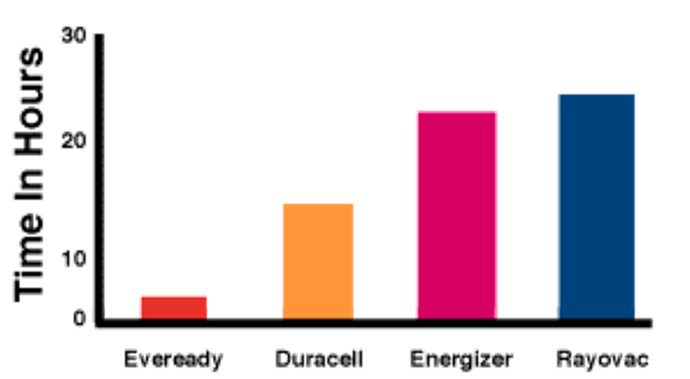

Is the graph an accurate representation of the results? (why/whynot): ________________________________________________________________________________ ________________________________________________________________________________
Why have the students used a bar graph and not drawn a line graph with a trend line? ________________________________________________________________________________ ________________________________________________________________________________
Analysis
The Eveready flashlight went out during the night, so we had to replace the batteries and watch it during the daytime. It was the only non-alkaline battery. We observed that when it was going dead, it got very dim. The alkaline batteries just went out completely.
We rejected our hypothesis that Duracell would last the longest. We came to this conclusion because our data show that Rayovac lasted longer than Duracell. This also proves that even though batteries may be more expensive (like the Duracell was), you might not be paying for a better battery.
We do suggest that further testing be done, due to a few errors made during the experiment. Some flashlights were accidentally dropped, which could have caused differences in the results. The expiration dates of the batteries were not all the same (there was a difference of a few months); so some batteries may not have been as "fresh" as the newer ones.
The students begin their Analysis with a statement about errors/method. This is not the correct format for an Analysis.
The first part of an Analysis should always be started with a simple statement about the results. Complete the following analysis using information from above.

The brand of D cell battery which lasted the longest was ________________ ( ___ hrs), followed by ________________ ( ___ hrs), ______________ ( ___ hrs), and _____________ ( ___ hrs). The top two performing batteries ( ___________ and ____________ ) were _______________ longer lasting than the other two batteries. The worst performing battery was the ____________, however it was a __________________ battery and would not be expected to last as long as _____________ batteries.
There were several errors which may have affected the results. The first ____________ battery did not last through the __________. This part of the experiment was repeated during the ____________ the following day. The ________________________ of the batteries varied (by several months). It is not known if _______________________ date affects the performance of the batteries, but this variable should have been _________________. In addition, several of the flashlights were ___________ during the experiment and this could have affected their performance.
It is recommended that further testing be done to confirm these conclusions. The amount of ____________ was significant enough to cast doubt on the validity of the result. Better control of _________________ should be done in any further experiments. The results indicate that even though some batteries may be more ____________, they do not provide more energy – a conclusion which should be investigated further.

Overall Grade:
What grade would you give this science report??? --- A⁺, A, A⁻, B⁺, B, B⁻, C⁺, C, C⁻, D⁺, D, D⁻, E⁺, E, E⁻,

YOUR COMMENT :

